https://www.digikey.com/en/products/detail/w%C3%BCrth-elektronik/653004113322/2508653?s=N4IgTCBcDaIGwFYDMAGFAWAjJpSwQF0BfIA
Female side I think
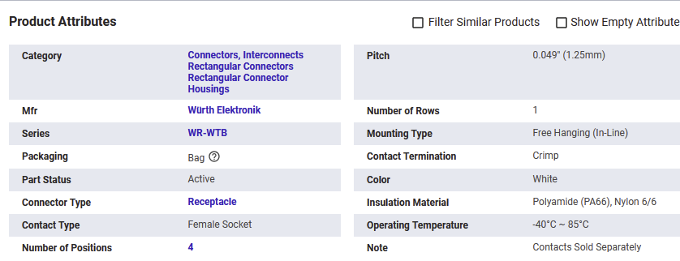

653004114822 male side

Wires https://www.digikey.com/en/products/detail/w%C3%BCrth-elektronik/648100130115/5658719 I think

